
Github
LinkedIn
Website

Participation Report on the Organisation of the CTF ISTEC Porto 2026

Document Information:

Title | Participation Report on the Organisation of the CTF ISTEC Porto 2026
Client | ISTEC Porto — Instituto Superior de Tecnologias Avançadas do Porto
Author | Samuel Oliveira
Date | 22 and 29 October 2026
Version | 1.0
Classification | Public

Version Control:

Version | Date | Author | Description
1.0 | 05/11/2026 | Samuel Oliveira | Initial version of the report.

Distribution:

Name | Role | Organisation
Samuel Oliveira | Organiser | ISTEC Porto

Table of Contents
Introdução 4
Âmbito e Autorização 5
Metodologia de Análise 6
Recomendações Finais 7
Conclusão 8

List of Figures
Right-click and choose "Update Field" (F9) to generate the list of figures.

Introduction
This report documents my participation in the organisation of the 1st edition of the CTF ISTEC Porto — Capture the Flag of Cybersecurity, a hands-on, jeopardy-style cybersecurity competition promoted by ISTEC Porto — Instituto Superior de Tecnologias Avançadas do Porto. The event took place over two dates: a preparation session (bootcamp) on 22 October 2026, and the competition itself on 29 October 2026.
In the CTF, 22 teams of 2 to 4 members competed, solving more than 30 challenges across several categories, ranging from beginner-level to areas such as OSINT, CTI, Web, Forensics, Cryptography, Reverse and Programming/Logic. As a member of the organising team, I contributed to the conception, preparation and running of the event, as well as to supporting the competition and the participants.
This report also includes a list of figures that visually accompanies the main moments, venues and results of the event, helping to contextualise each stage I describe.

Background and Organisation of the Event

About ISTEC Porto
The CTF was promoted by ISTEC Porto — Instituto Superior de Tecnologias Avançadas do Porto, a higher-education institution in the field of technology. More information at istec-porto.pt. The 1st edition aimed to bring students closer to cybersecurity, to foster problem-solving, critical thinking and teamwork, and it was open to students with no prior experience.

Format, platform and links
The competition followed the jeopardy format, in which teams solve challenges to find codes ("flags") that award points. As a rule, flags had the format ISTEC{text} and were case-sensitive. The competition ran on a CTFd platform instance, hosted on infrastructure within the European Union.
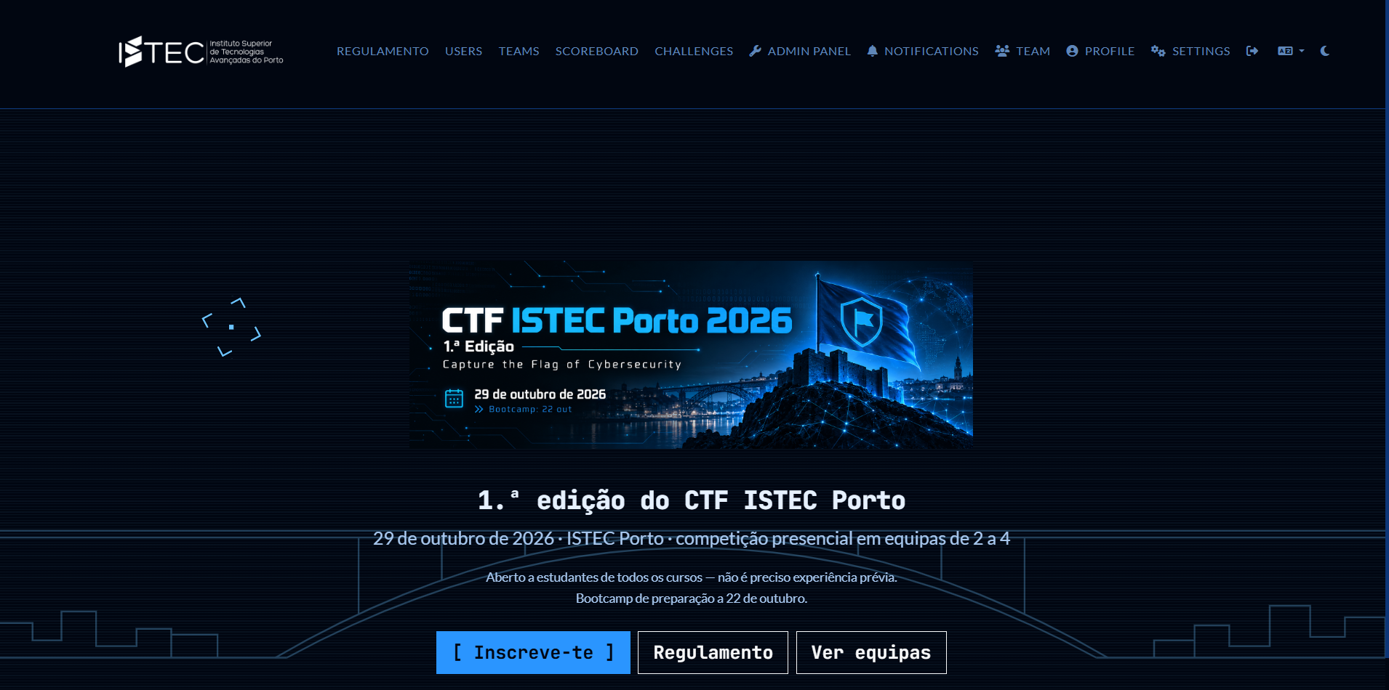
Figure 1 – Home page of the CTFd platform for the CTF ISTEC Porto 2026.
The main links for the event were:
- ISTEC Porto website: https://istec-porto.pt
- Registration and competition platform (CTFd): https://ctf-istec.polandcentral.cloudapp.azure.com/register

Categories and challenges
The platform featured 43 challenges spread across eight categories with different difficulty levels. Each challenge had a fixed value of 100, 200, 300 or 400 points, depending on its difficulty, for a total of 8100 points at stake. Some challenges offered hints — some free, some costing points — and certain challenges depended on first solving others.
The distribution of challenges across categories was as follows: Web (18), OSINT (7), Misc (6), Cryptography (4), Forensics (3), Reverse (2), CTI (1), Beginner (1) and Programming/Logic (1).

Organising team
The event was organised by the lecturers Mário Amorim (coordination) and Nuno Fonseca, with the support of students from the BSc in Computer Engineering. Besides me, the team included:
- Mário Amorim — Coordination (ISTEC Porto lecturer).
- Nuno Fonseca — Co-organisation (ISTEC Porto lecturer): https://www.linkedin.com/in/nuno-fonseca-33b2452/
- Vanina Kollen — Organisation (student): https://www.linkedin.com/in/vanina-kollen-337762397/
- Ana Rita Monteiro — Organisation (student): https://www.linkedin.com/in/ana-rita-monteiro-b186a8359/
- Rafael Batista — Organisation (student): https://www.linkedin.com/in/0xadamastor/
- José Samuel Oliveira (Ph0enix) — Organisation (student): https://www.linkedin.com/in/jose-samuel-oliveira/
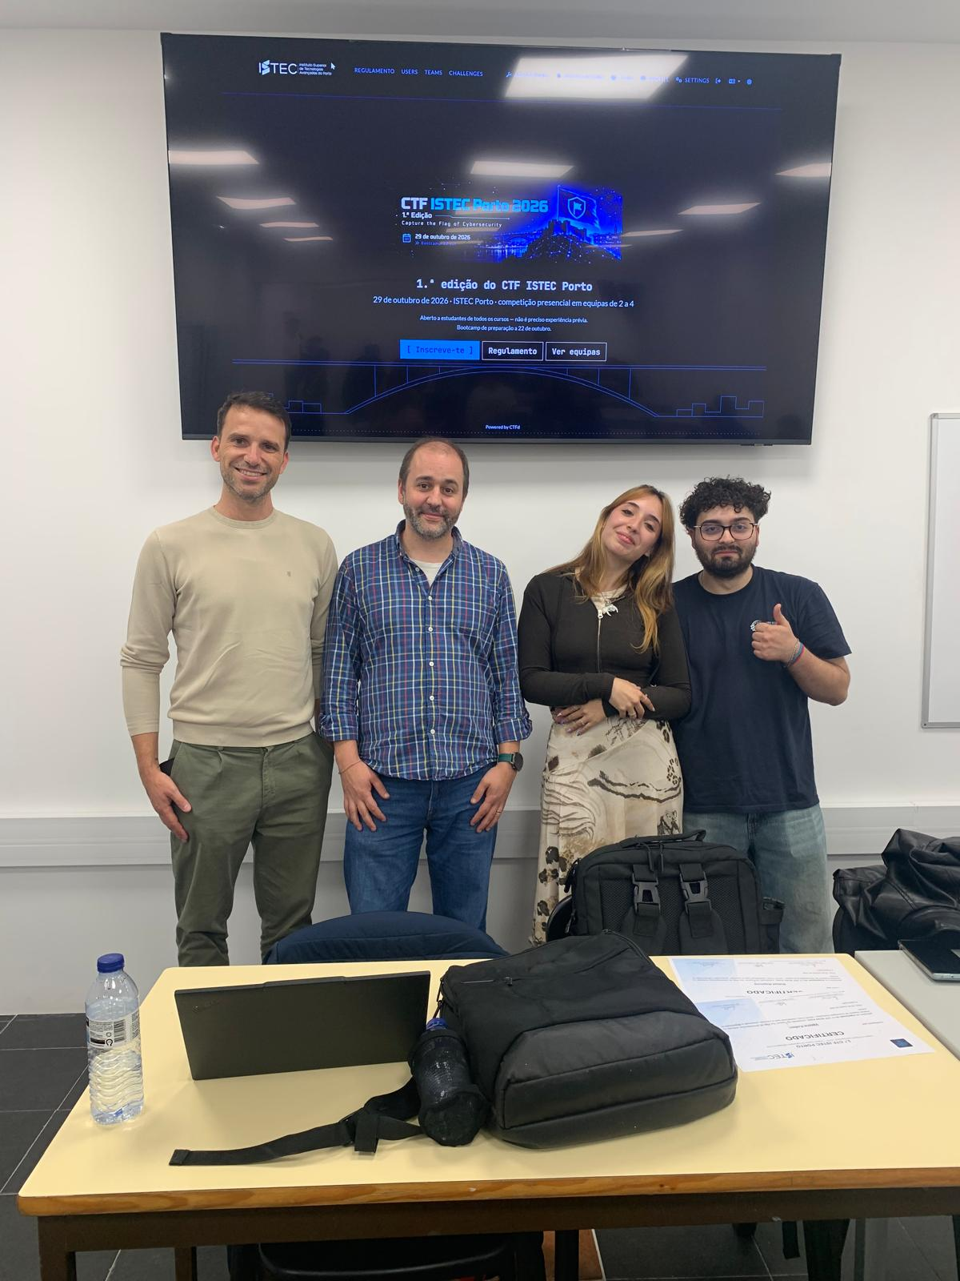
Figure 1 – Part of the CTF ISTEC Porto organising team.
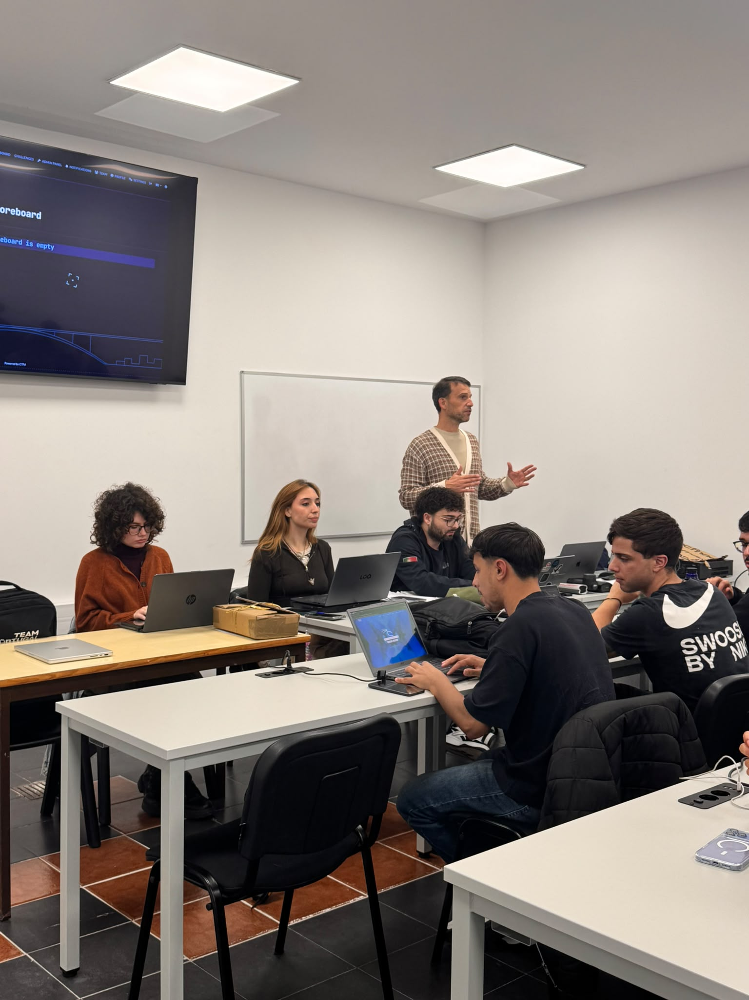
Figure 1 – Organising team of the CTF ISTEC Porto (2).
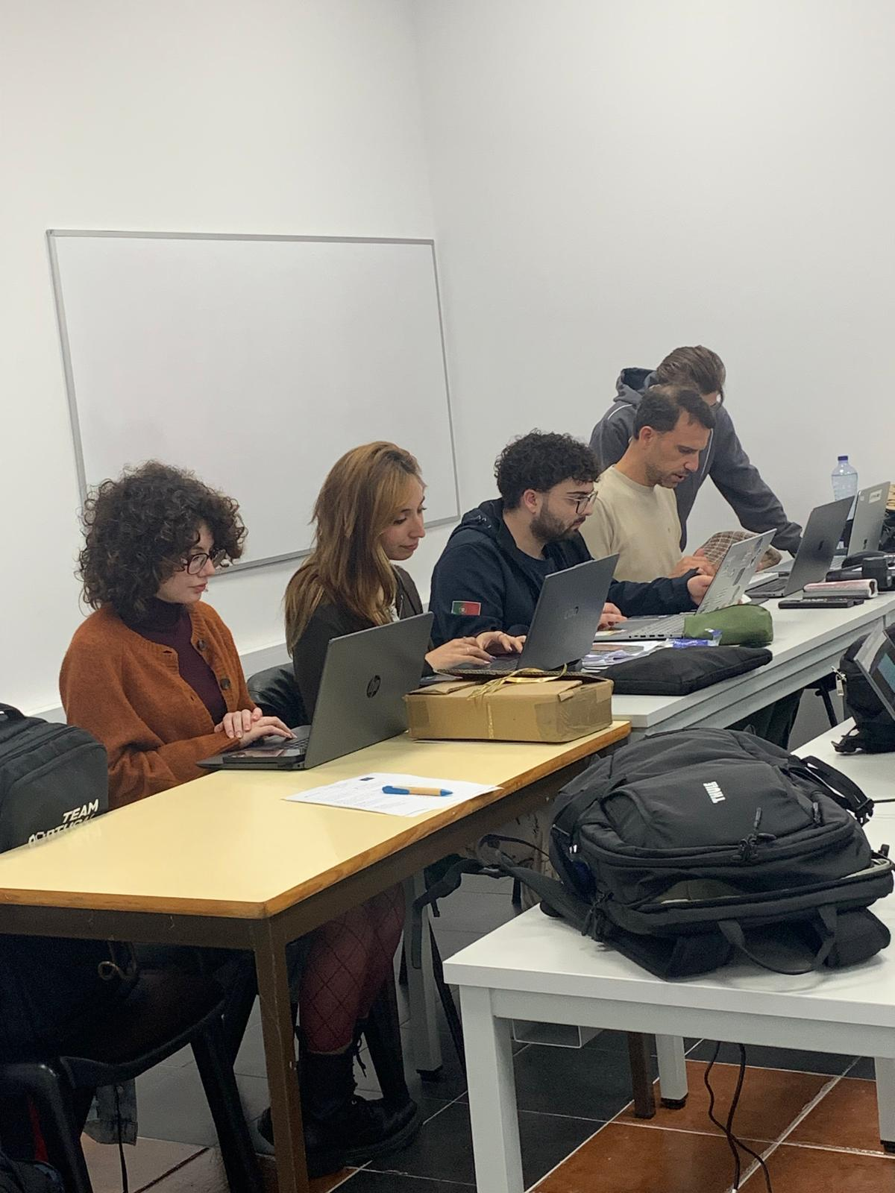
Figure 1 – Organising team of the CTF ISTEC Porto (3).
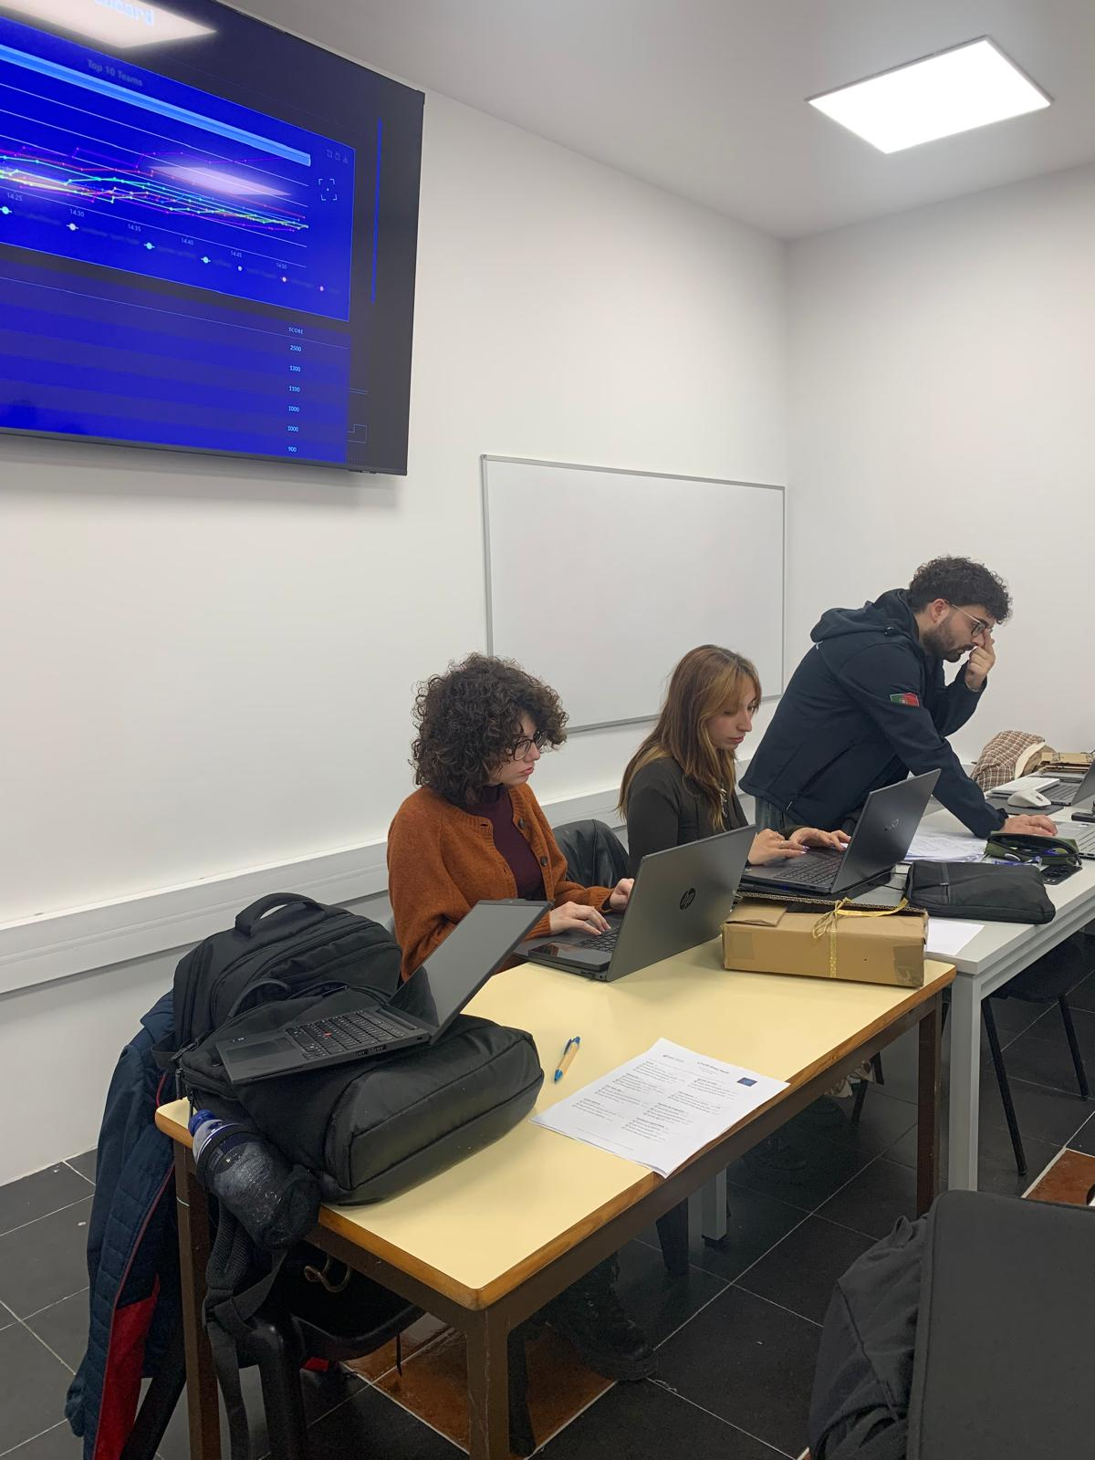
Figure 1 – Organising team of the CTF ISTEC Porto (4).

Rules and Regulations
The event was governed by its own set of regulations, approved for the 1st edition. The main points are:
- Eligibility: open to students of any course and year at ISTEC Porto, with no prior cybersecurity experience required.
- Teams: participation in teams of 2 to 4 students, each team with at least one laptop.
- Registration: free, from 15 to 26 October 2026, using the institutional email address (@my.istec.pt), limited to the room capacity.
- Scoring: challenges worth 100 to 400 points; paid hints deducted from the score; ties broken by the team that reached the score first and then by the number of challenges solved.
- Conduct: use of the Internet, public documentation, security tools and generative artificial intelligence was allowed; attacking the infrastructure, sharing flags between teams, automating submissions or using multiple accounts was forbidden.
- Prizes and certificates: prizes for the top three teams, a "Rookie" (Revelação) prize for the best eligible team, and a certificate of participation for everyone who stayed until the end.
The regulations also included data protection (GDPR) and image-rights rules, with ISTEC Porto acting as the controller of the data collected.

Preparation Session (Bootcamp) — 22 October
On 22 October 2026 a preparation session (bootcamp) was held, optional and especially recommended for those who had never taken part in a CTF. In this session we explained to participants how to approach and solve challenges across the various categories, presenting the tools best suited to each one. The goal was to lower the barrier to entry and allow students with no experience to arrive at competition day more confident.

CTF Day — 29 October

Accreditation and opening session
The competition took place on 29 October 2026, at the ISTEC Porto premises. Accreditation began at 1:30 p.m., confirming the students’ attendance, and the opening session was held at 2:00 p.m.

Competition
The competition ran from 2:15 p.m. to 5:15 p.m., bringing together 22 teams of 2 to 4 members who competed against each other to solve the challenges. Throughout the afternoon, the organisation supported the teams, answering questions about the platform and the regulations, without helping to solve the challenges.
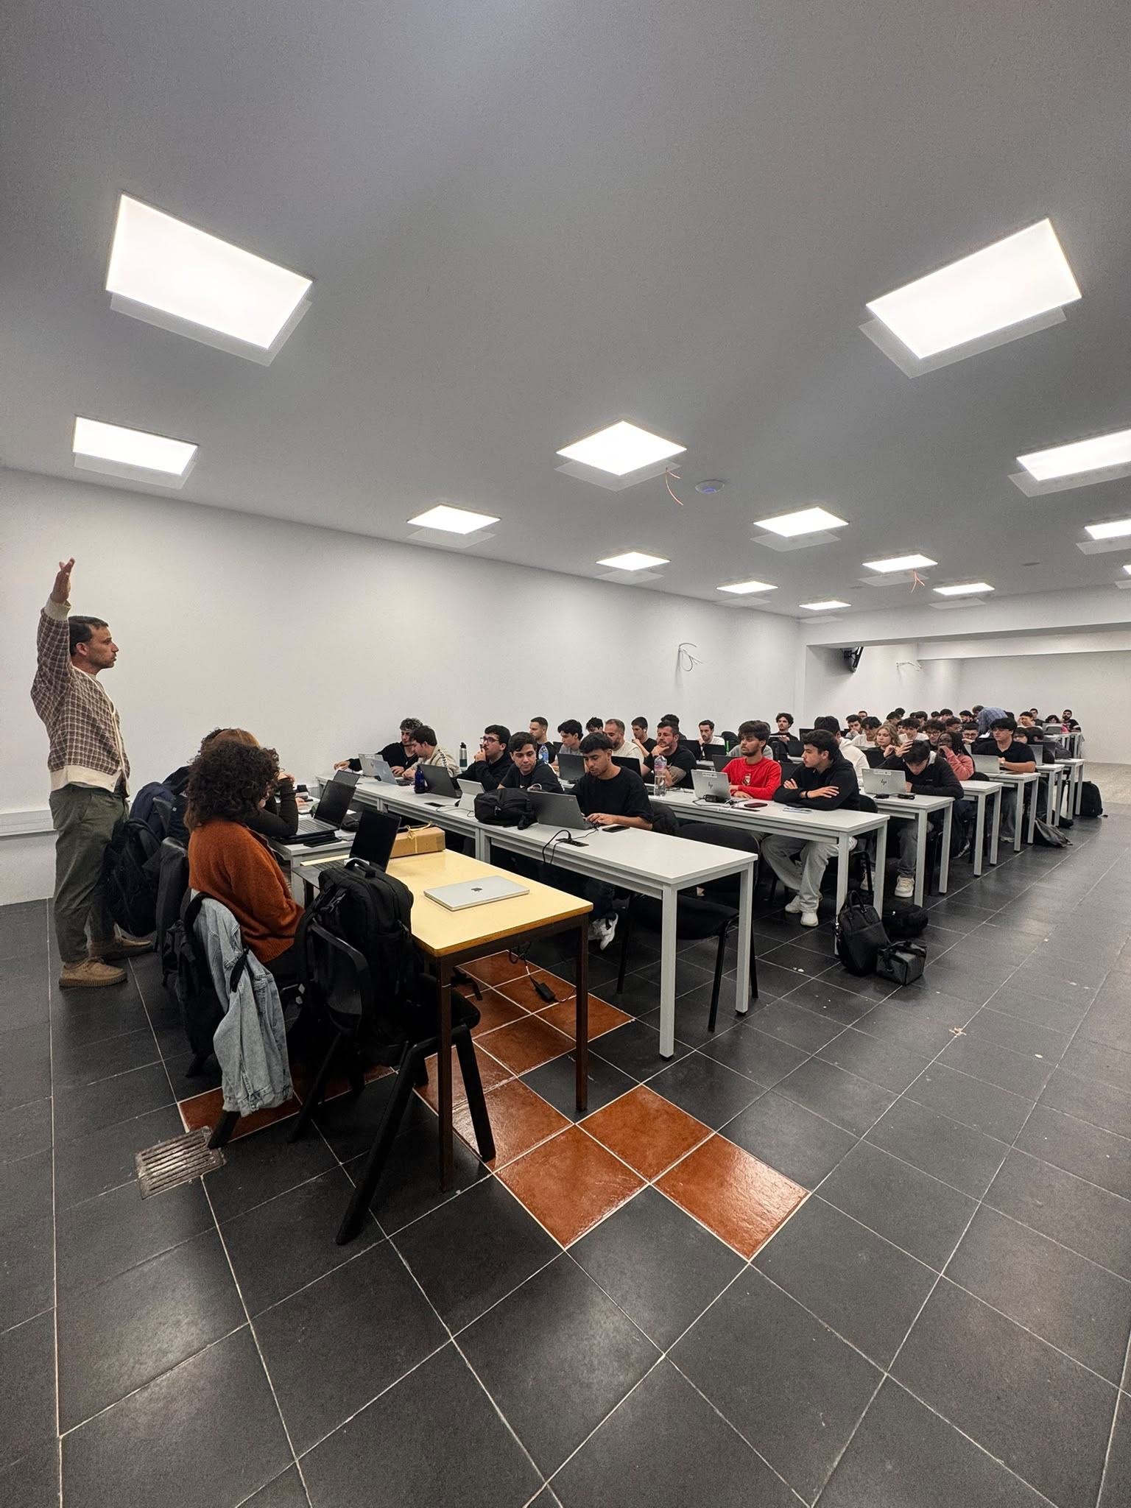
Figure 1 – Competition room with the participating teams during the CTF.
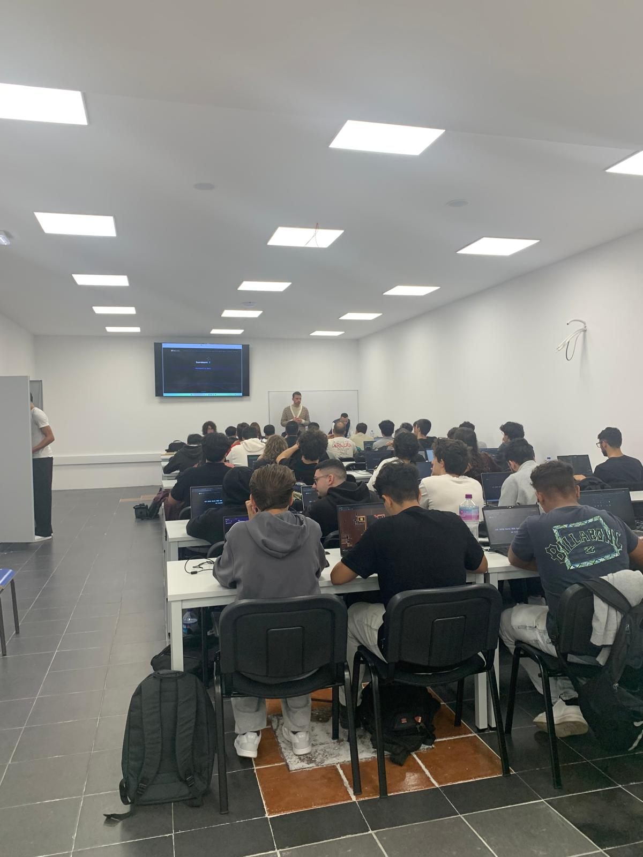
Figure 1 – Participants solving challenges during the competition.

Coffee break
During the event a coffee break was offered to the participants, providing a moment to pause and to socialise between the teams and the organisation.

Figure 1 – Coffee break offered to the participants.

Walkthroughs and prize-giving
After the competition closed and the complaints were reviewed, from 5:30 p.m. onwards there were walkthroughs of some of the challenges and the prize-giving to the winning teams.

Results and Statistics

Overview
The platform recorded 88 users and 26 teams (of which 22 scored and appear in the final leaderboard), from 265 distinct IP addresses. There were 43 challenges and 8100 points at stake. The most-solved challenge was "Lê as Regras" (22 solves) and the least-solved was "Ecos of the Past (2/3)" (1 solve).
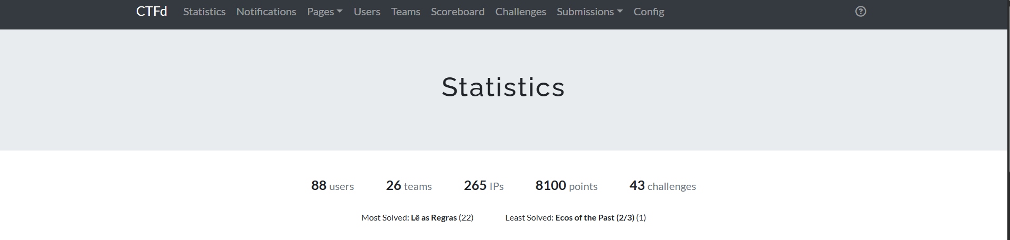
Figure 1 – Overview of the platform statistics: 88 users, 26 teams, 43 challenges and 8100 points.

Breakdown by category and points
The figures below show the distribution of challenges and points by category. The Web category was by far the most represented, with 18 challenges (41.9%) and 3500 points (43.2%), followed by OSINT, with 7 challenges and 1500 points.
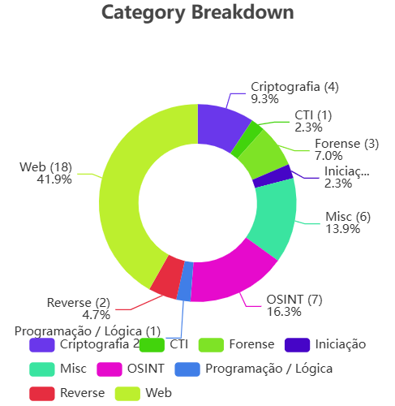
Figure 1 – Breakdown of challenges by category.
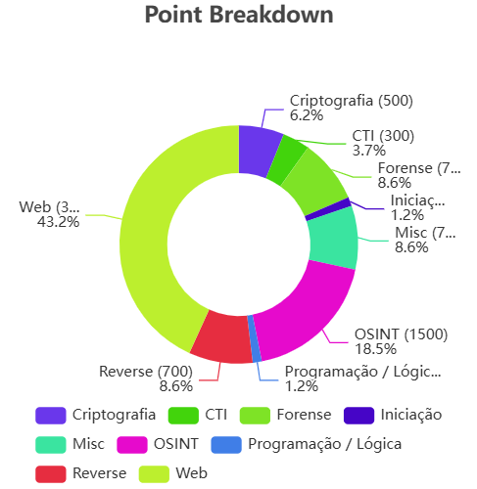
Figure 1 – Breakdown of points by category.

Solves per challenge
Looking at the challenges individually, there is a wide range in the number of solves: some beginner challenges were solved by almost every team, while the hardest ones went unsolved or were solved by only one or two teams.
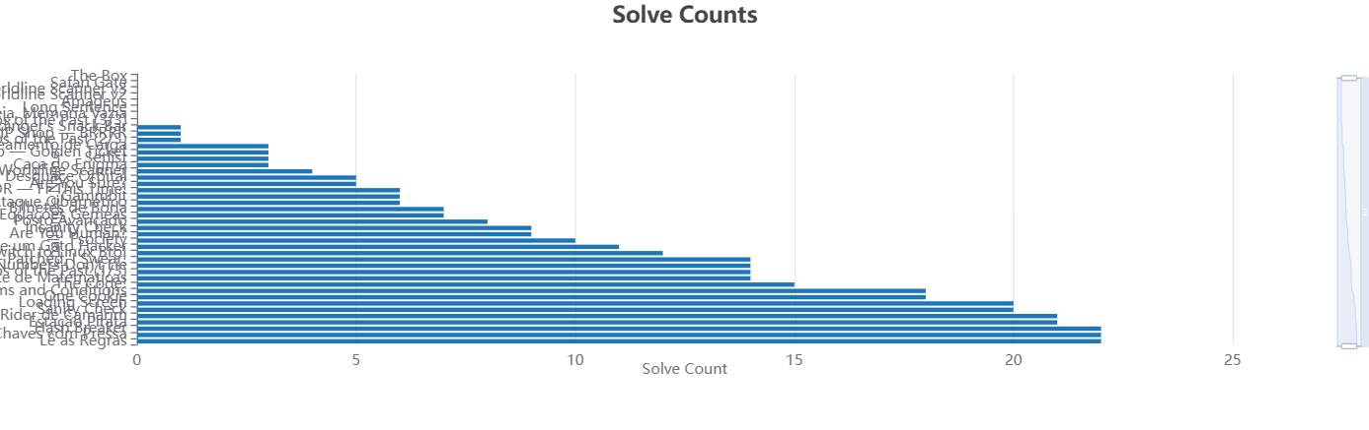
Figure 1 – Number of solves per challenge.
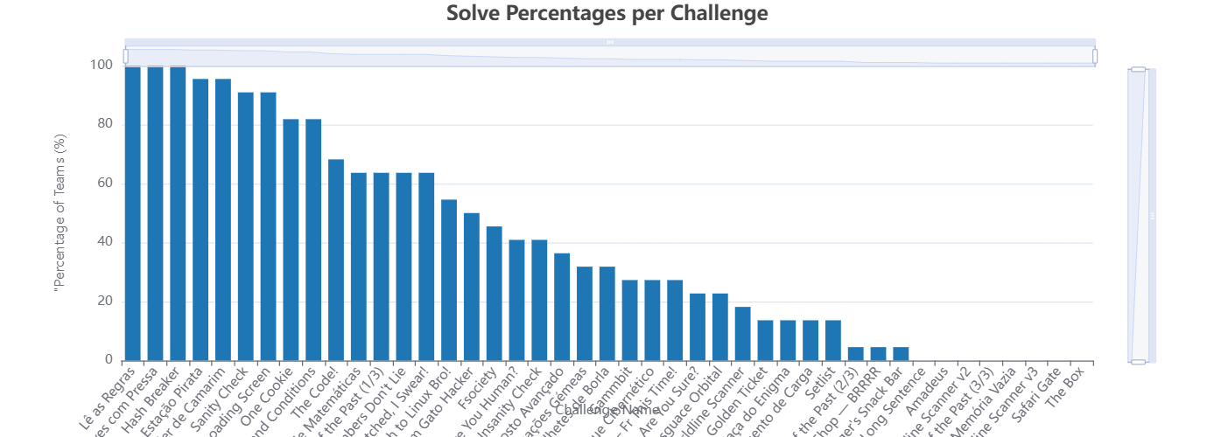
Figure 1 – Percentage of teams that solved each challenge.

Score and submission distribution
Over the course of the competition 2028 flag submissions were made, of which 379 were correct (18.7%) and 1649 were incorrect (81.3%). The distribution of final team scores is fairly spread out, with most teams scoring between 900 and 2000 points.
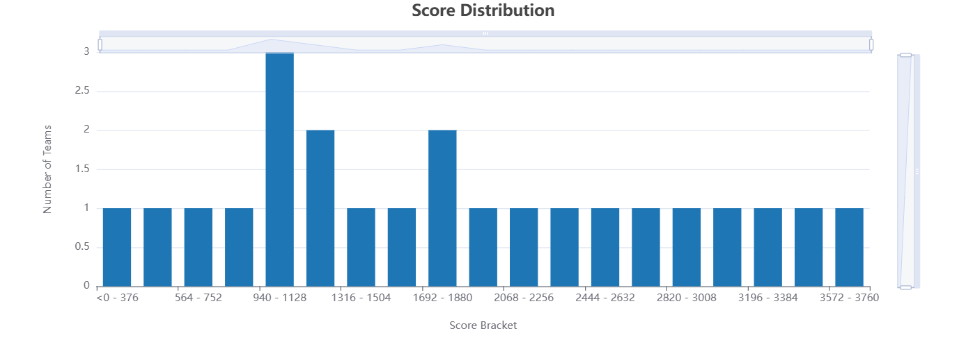
Figure 1 – Distribution of team scores.
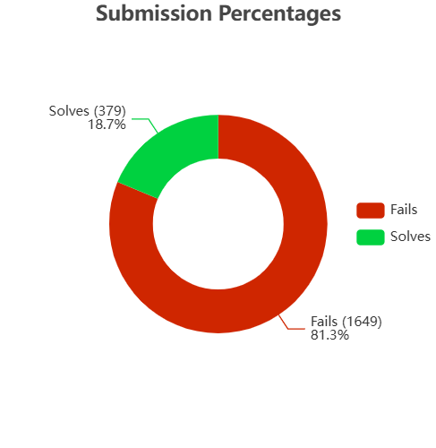
Figure 1 – Percentage of correct and incorrect submissions.
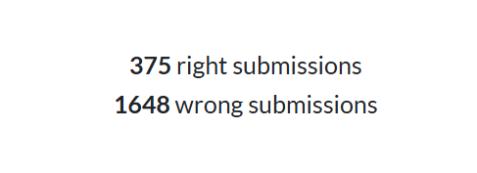
Figure 1 – Total of correct and incorrect submissions.

Progression and list of teams
The score progression of the top 10 teams throughout the afternoon shows a closely-fought competition, with several changes of position right up to the final part of the event.
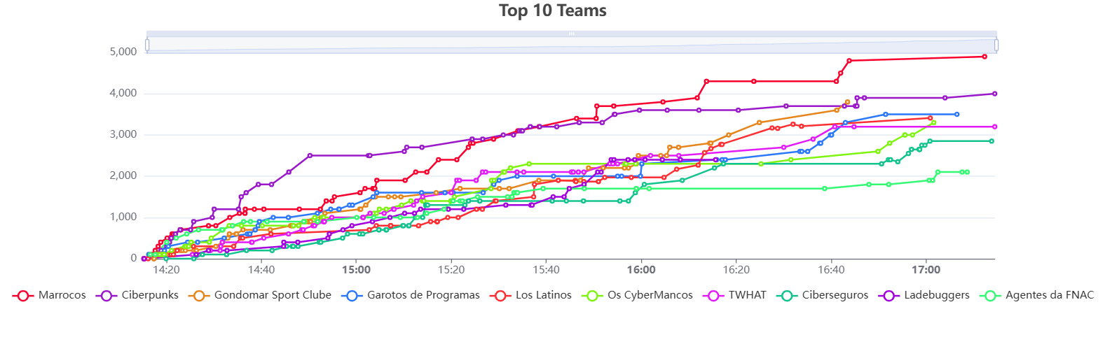
Figure 1 – Score progression of the top 10 teams throughout the competition.
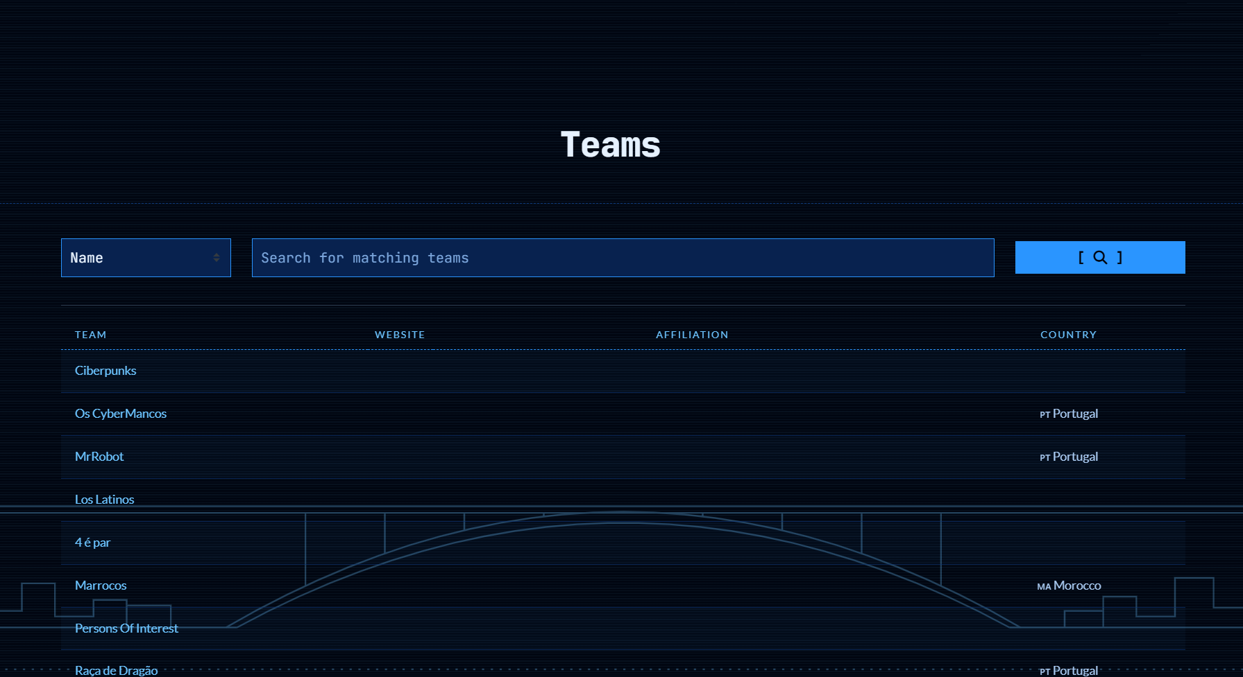
Figure 1 – List of teams registered on the platform.

Final leaderboard
The final leaderboard of the 22 scoring teams was led by the team "Marrocos" (4900 points), followed by "Ciberpunks" (4000) and "Gondomar Sport Clube" (3800). The figures below show the complete table.
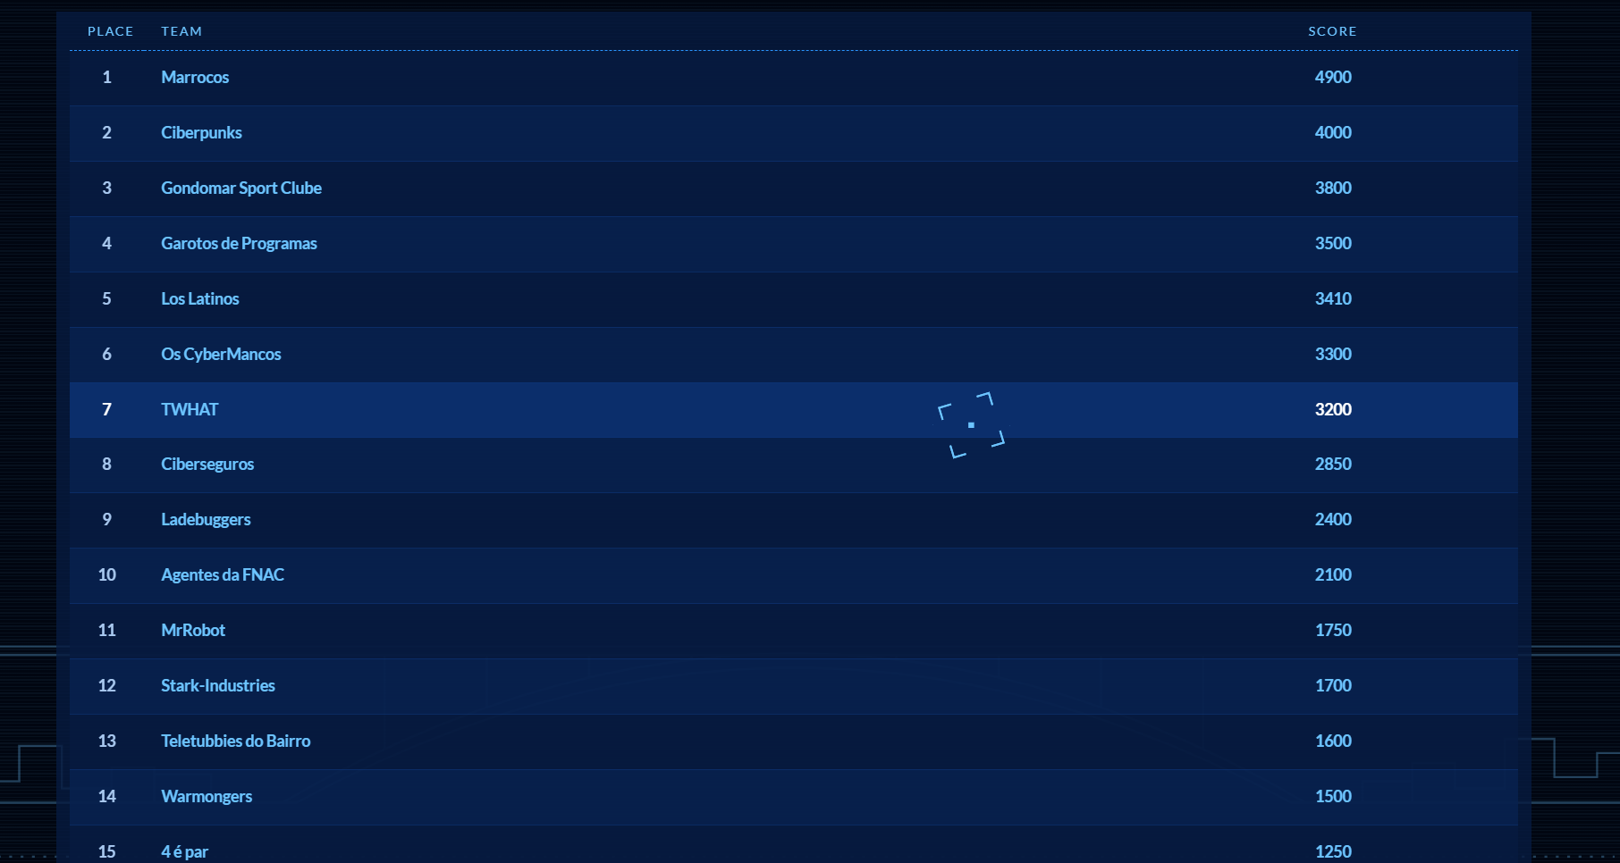
Figure 1 – Final leaderboard (1st to 15th place).
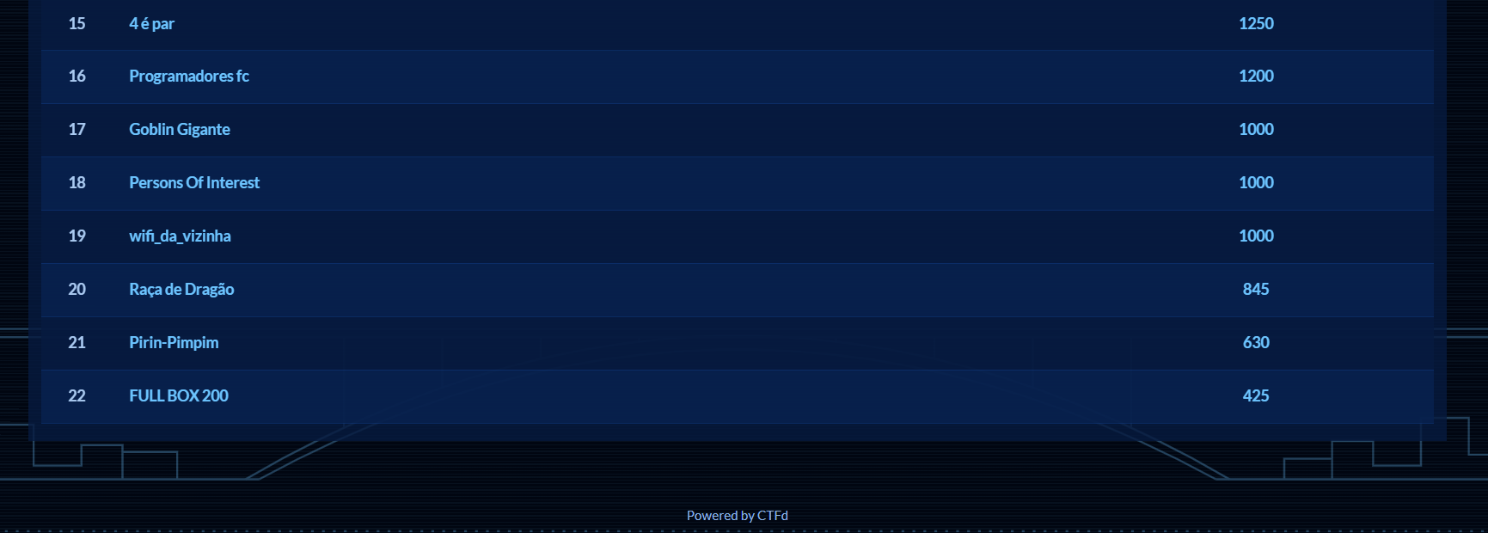
Figure 1 – Final leaderboard (15th to 22nd place).

Podium, Winners and Recognition

1st place — Marrocos
The winning team, "Marrocos", finished in 1st place with 4900 points. It was made up of:
- Gonçalo Manuel Albuquerque Marinho: https://www.linkedin.com/in/gon%C3%A7alo-manuel-albuquerque-marinho-aa058a284/
- Filipe Calatré: https://www.linkedin.com/in/filipe-calatr%C3%A9-973343395/
- Bruno Lamela: https://www.linkedin.com/in/bruno-lamela-b84746335/
- Luiz Peneda (no LinkedIn).
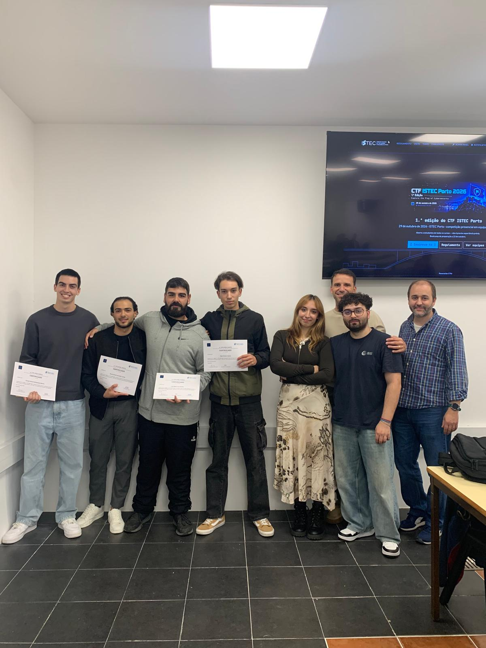
Figure 1 – Winning team, "Marrocos" (1st place), with the organisation.

2nd place — Ciberpunks
Second place was taken by the team "Ciberpunks", with 4000 points.
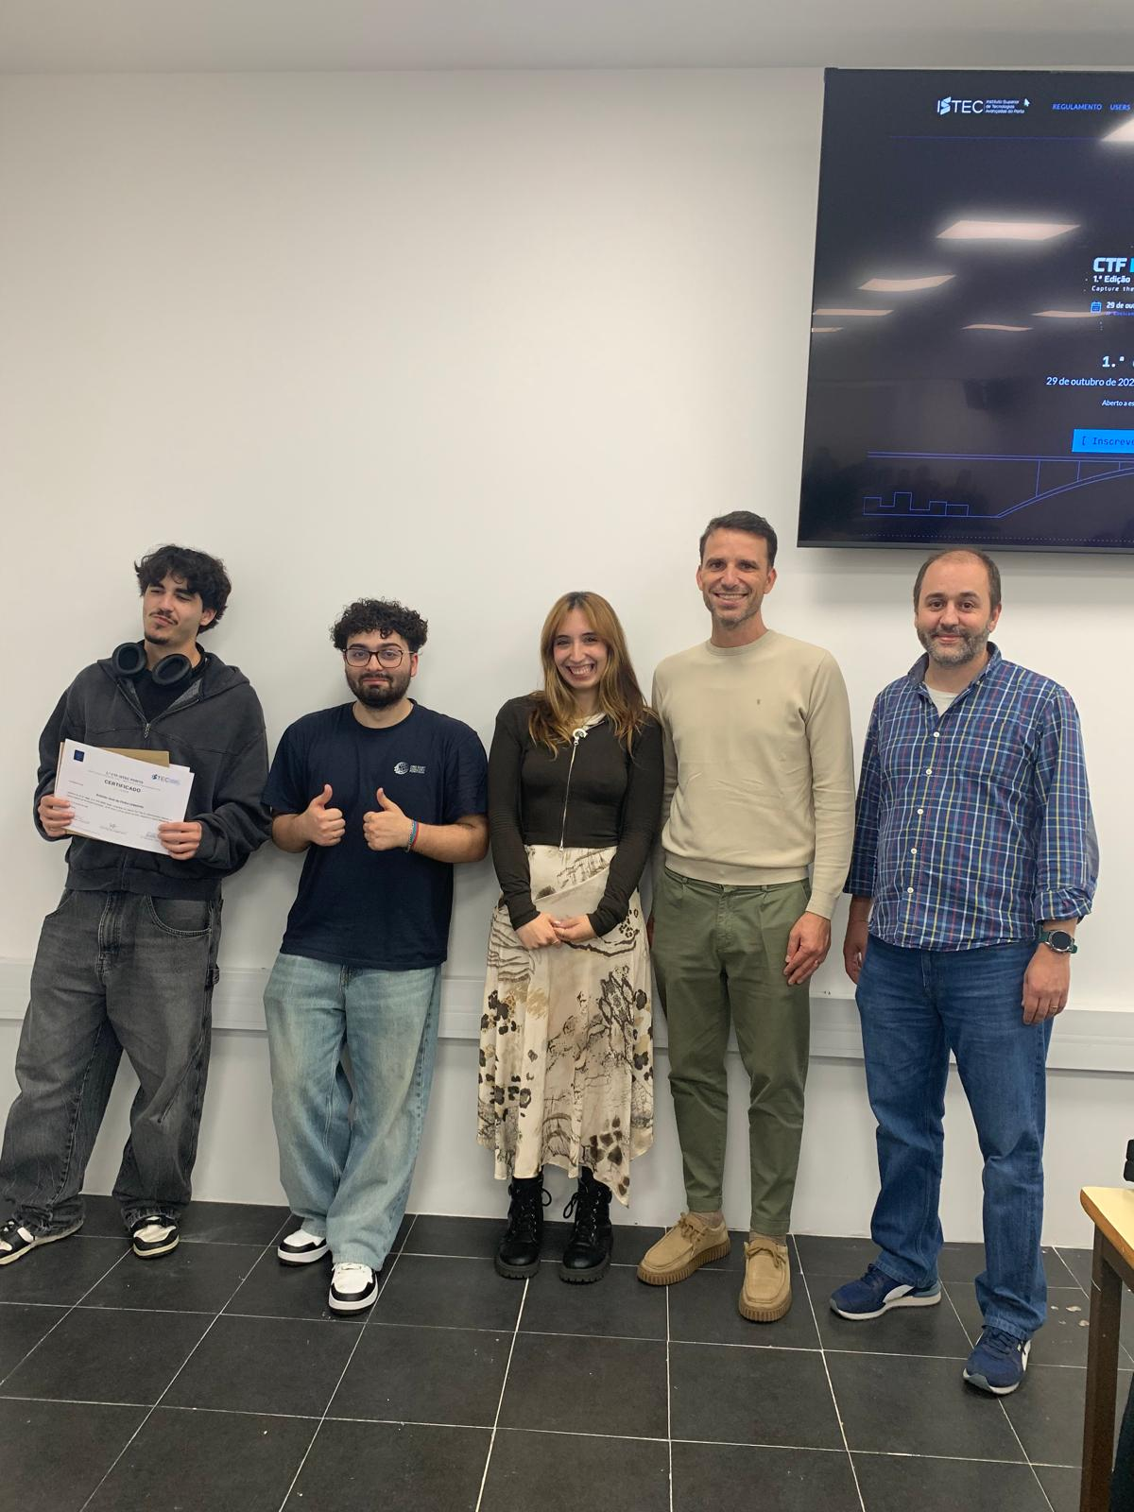
Figure 1 – "Ciberpunks" team (2nd place), with the organisation.

3rd place — Gondomar Sport Clube
The third spot on the podium was taken by the team "Gondomar Sport Clube", with 3800 points.
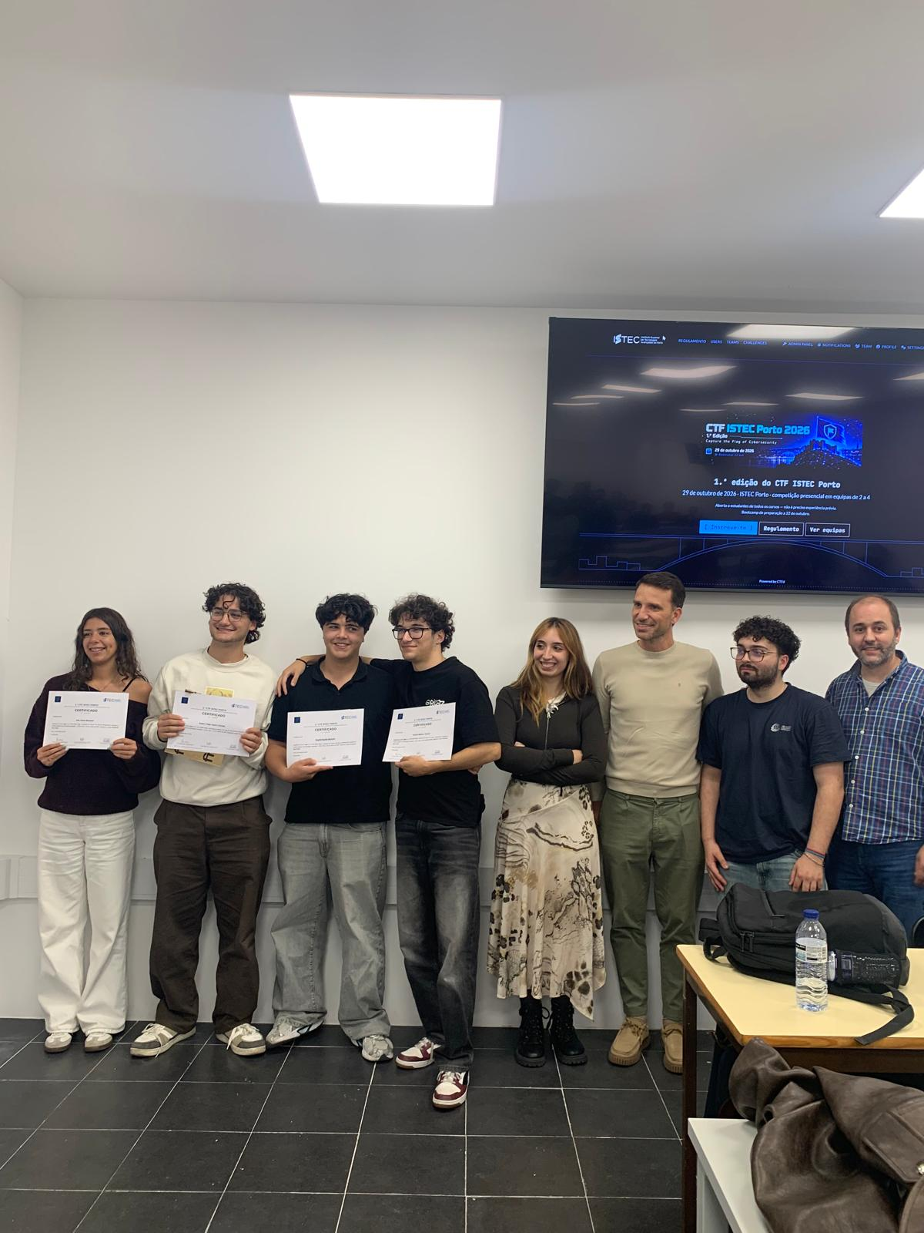
Figure 1 – "Gondomar Sport Clube" team (3rd place), with the organisation.

"Rookie" prize (Revelação)
The "Rookie" prize (Revelação) was awarded to the best-placed eligible team whose members were, individually, first-year students and/or students from courses outside the IT field. The awarded team received an FNAC voucher.
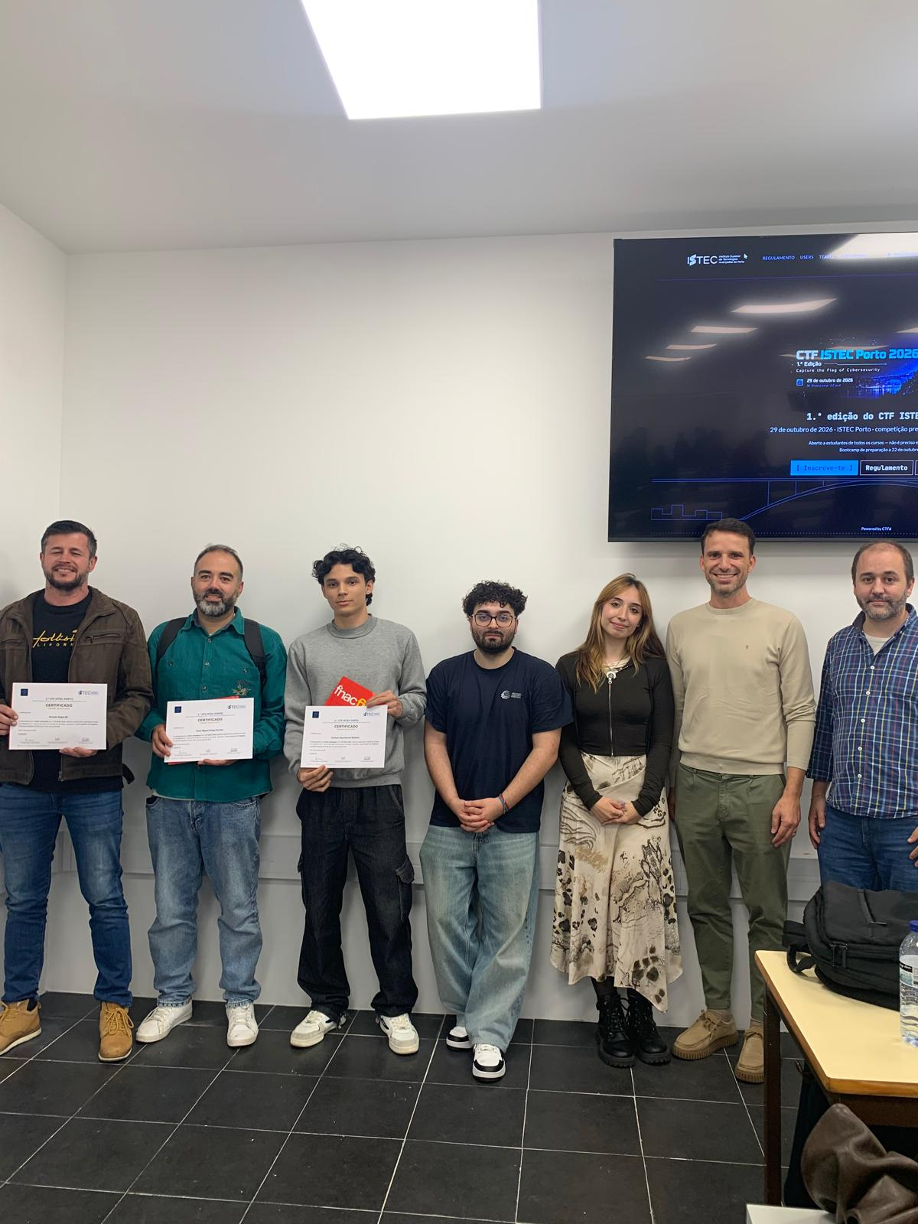
Figure 1 – Team awarded the "Rookie" (Revelação) prize, with the organisation.

Trophies and keepsakes
The trophies for the winning teams and the commemorative keychains handed out were 3D-printed, with a cybersecurity-themed design. Everyone who stayed until the end of the competition also received a certificate of participation.
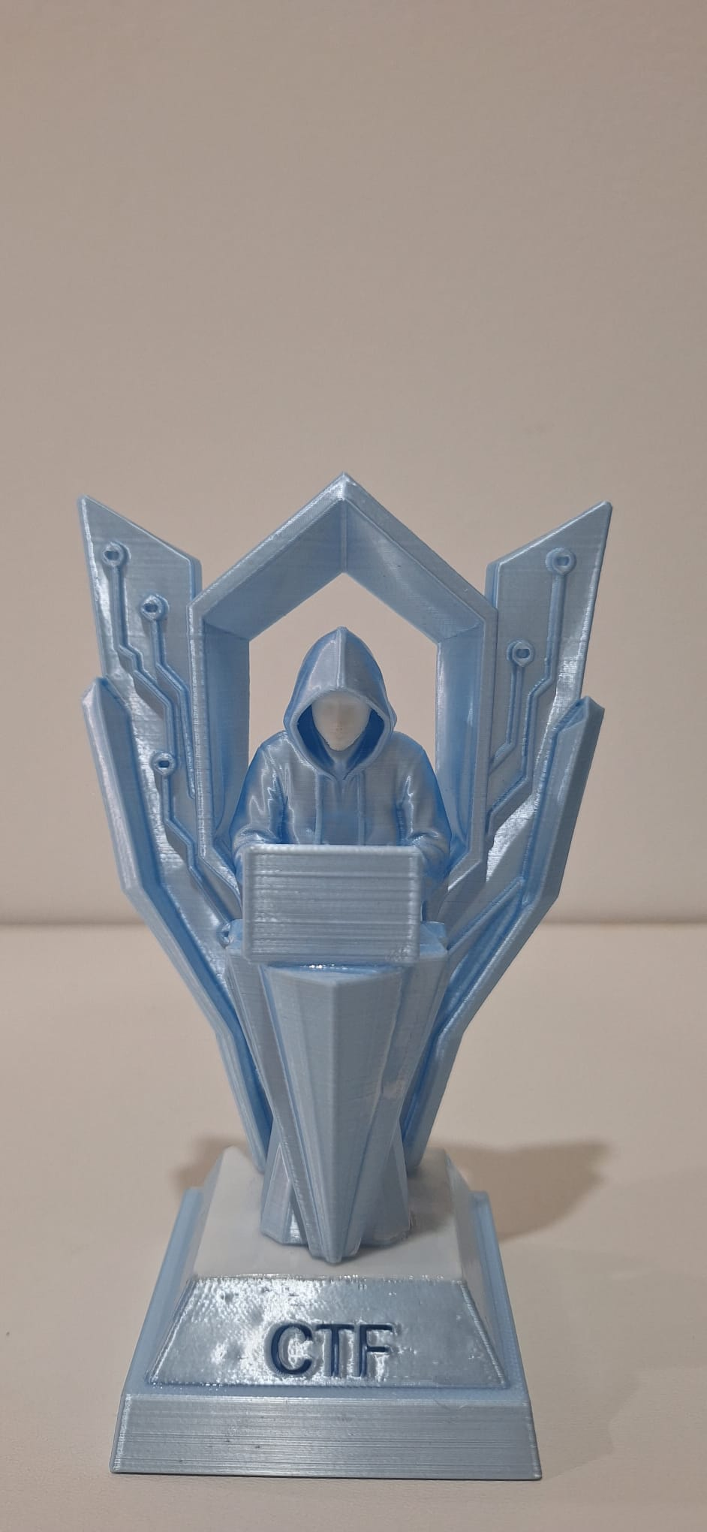
Figure 1 – CTF ISTEC Porto trophy, 3D-printed (front).

Figure 1 – Commemorative CTF ISTEC Porto keychain, 3D-printed.

Critical Analysis and Recommendations
Overall, the 1st edition of the CTF ISTEC Porto was very positive. Turnout was strong, the competition ran without any significant incidents, and the atmosphere was one of great enthusiasm and good spirits, fulfilling the goal of bringing students closer to cybersecurity. The preparation session proved important for including participants with no prior experience.
Even so, I leave a few recommendations for future editions:
- Strengthen the balance between categories, since the Web category concentrated a large share of the challenges and points.
- Add more intermediate-difficulty challenges, to reduce the gap between the beginner challenges and the most advanced ones.
- Keep promoting the preparation session (bootcamp) and, if possible, provide supporting materials ahead of the event.
- Maintain and value recognition initiatives, such as the "Rookie" prize, which encourage participation from students of other fields and years.

Conclusion
Taking part in the organisation of the 1st edition of the CTF ISTEC Porto was a very rewarding experience, both technically and personally. It was fulfilling to see dozens of students competing, learning and having fun with cybersecurity, many of them for the first time.
I hope this first edition is the start of a tradition at ISTEC Porto and that future editions are even bigger, more diverse and more challenging, consolidating cybersecurity as an area of interest and of the future for students.


Github
LinkedIn
Website

